Critical Spirit an Open Door - Spiritual Warfare 3
August 3, 2016
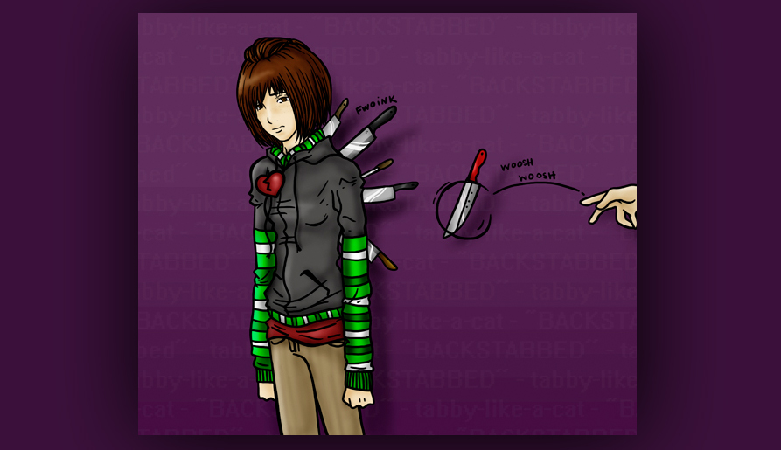
Well, Heartdwellers, the Lord is taking us by the hand and helping us cross the Santa Monica Freeway at rush hour…without getting run over. Just sayin… We are continually crossing fast-moving traffic in the spiritual realm. And we’ve been creamed in the past; but this is a new day.

During worship, Jesus came to Me and said, “I’m proud of you. You are doing much better with judgment.”

Thank you for helping me, Lord. I hate my pride, judgment and critical spirit - they are absolute poison.

"You can say that again."

They are absolute poison!!!

(We giggled.) Nonetheless this is a serious, serious issue.

"It is, and you are finally beginning to understand the scope of it in your life. It explains why there have been a lot of attacks. The critical spirit is a fast door-opener."

And then He said, "Share with them your experience."

I figured I’d be doing this again…

He replied, "Always. It really helps so many of My children to come to terms with their faults, because you are transparent about yours."

OK. This morning, Ezekiel and I were praying the binding prayer together. And halfway though it, I had the strongest understanding that the battle is in our own hearts more than anywhere else. What good does it do to pray the binding prayer, when I turn around in the next breath and have an accusatory thought, which I follow up on with my own thinking, topping it off with condemnation for that person?

It does no good, dear ones. You might as well forget praying the binding prayer if you are going to continue with judgment and a critical spirit.

I also wanted to share with you, that when He allows suffering because you did have a critical spirit and injured someone else - part of that suffering is for your correction. Part of that suffering is to comfort that person, because they need spiritual healing - so it's a fast offering for them. And part of it is applied to lost souls in the world. So, in other words, the Lord is continually using anything we have as a fast offering, for the work of redeeming souls.

So, don’t feel like all is lost if you opened a door. The attack from that is partly to correct you, partly for souls, because you have consecrated yourself to the Lord and given all that is yours into His hands. And it's like a fast offering behind missionaries, so to speak, just the gospel message can be delivered and hearts will be opened. And part of it is a fast offering for the healing of the person you've injured by your words.

But every time I open my heart and mind to be critical of others or hold judgments, every single time…I’m cutting off my nose to spite my face. Not a pretty sight. When Holy Spirit quickened the thought to me that praying the Binding Prayer wasn’t going to cover the day unless my heart stayed in the place of charity, I realized how very serious this is.

At that point, the Lord began speaking again, “It is a fact. When you are critical of others, even in your heart or mind without saying a word, you have just opened a door. Not only that, but the thought sticks to the person you criticized and hurts them. So, first you must repent of the thought which you followed up on; then you must pray for the person you just injured.

"This is a spiritual law. So few Christians realize it. The ones that do and live by it are very high up in ministry, because I can trust them. Other ministers, once they get into name calling or accusation, all the demons that have been waiting in line for years fly in the open door and begin oppressing them. The more harm that is done, the worse the oppression they will suffer. And some will even lose their lives. This is a law, a dynamic of the spiritual realm.

"My Children, say NOTHING evil about anyone. Do not linger on an evil thought, do not entertain it, do not follow up on it. Do not. I tell you this for your own good. If you do this, you will suffer. You have just stabbed one of My children in the back and opened a door. Much damage comes through just one critical thought.

"And by the way, most of what you accuse others of, you have been guilty of at one time or another - and the accusation may not be grounded in fact.

"Very often the devils will goad you on with all kinds of thoughts about people who have hurt you, or you feel have done you wrong. They are like cheerleaders cheering you on. They goad you to make all kinds of nasty connections and accusations. Most of the time what they say is pure, unadulterated lies with no basis in fact. You have been very guilty of this, Clare. That’s why you are getting so much calumny - at least one reason.”

And then, I broke in at this point and said, 'Yes, when we were on the mountain we had people who were known Satanists constantly coming on our property under the guise of an innocent trek in the woods. But there were others that came by, and we didn’t know if they were part of the coven or not. But by assuming they were, we opened a huge door, because some of them were just curious and were innocent of any wrong-doing.’

And I think here, it is important to note, we were barraged and provoked by demons to accuse everyone we came in contact with. And that was my downfall.

Jesus continued, “It is important to note that when your mind is perceiving thoughts that are critical of others, you may be picking up on what the enemy is broadcasting to deliberately lead you into judgment, so they can walk right into that open door. In fact, many come with the assignment to open the door and then proceed through it, so they work very hard at getting an opening. Until that door is open, they are stymied.

"This is why, My People, I have continually told you, from the very start, not to judge and to stay away from the news. The news is slanted to get you to criticize. It doesn’t matter whether it is true or not, whether you started it or not. All that matters is that you took it upon yourself to judge another, and most of the time without even knowing the facts.

"When the so-called facts are lies, then you become complicit in the sin of false accusation. Do you see the wisdom in this, My Brides? The media is being used by Satan to provoke you into judgment so there are open doors in your lives, and the enemy can penetrate and wreak havoc. I very much want you to make this connection, so that you can protect yourself."

Lord, is it ever safe to watch the news?

"The information you get from missionaries is for the most part honest, and gives you an occasion to pray and offer gifts. But the news which is politically controlled is divisive, misleading and manipulative. I wish all My People would come to Me for the news and I will tell them what is important for them to know or pray about. This is why I will send something across your desk, without you asking. But even then, Clare - be vigilant.

"But even in your correspondence, or conversations, watch out when people are having difficulties and are accusing others left and right. It isn’t healthy to engage these things, and most of the time the information is slanted to their advantage and you become complicit in false accusation."

Wow...this really gets convoluted and tricky...!

He continued, "I wish you could all see the knives I pull out of the backs of Christians daily. You would not believe the extent to which this is being done all over the globe. And not by Muslims or Communists, but by other Christians. And then they wonder why they’ve come under such heavy oppression."

I would like to share something with you, Dear ones. You know how you can be in a hurry or get irritated because your loving spouse misplaced something or used something important without thinking it through or asking? This is the most common source of sin in my life. I tend to be very impatient and guarded about my time, because I never finish a day having written to everyone as I should have. Or worked on the painting, or worked on music. So, I am very, very jealous with my time. And if something inconveniences me or makes more work for me, I get resentful.

Guys, this is a terrible poison! Even when you hold it in, it damages you and your spouse. Resentment builds, and pretty soon you have a full cesspool of effluent. Those little things that can irritate and cause you to sigh and wish that hadn’t happened? If you don’t catch those the very moment they come to mind, you're allowing a seed which can take root and make a very deep crater in your relationship, full of unspoken resentment. And you don’t even realize from day to day that it is there, until another thing gets flushed down the drain. It does get full guys, it really does. But worse than that, is the door you opened by being critical. That allows the demons to come in and sift you in so many ways - it’s a huge open door, bringing with it ingratitude.

What’s the answer? Brotherly love. Making excuses for one another. Thinking back to a time when you did the very same thing or worse. It levels the playing field and you can’t criticize them for what you just did last week! Calling to mind their wonderful virtues and all the times they were there when you needed them. And considering how faithful they’ve been to you, though you have let them down many times as well.

Remember back to when you didn’t have someone who truly loved you and shared in your troubles, really caring for you. That in itself is very sobering. Consider how you would feel if they were gone tomorrow. That really helps with appreciation. These are all ways to get ahold of your thoughts - taking every thought captive and submitting it to Christ in all His Divine Humility. He Who humbled Himself, dying the death of a sinner just to have His Church in Heaven with Him. We have not resisted to that point yet - so what do we have to complain about??? Here, I’m preaching to myself.

The Lord continued, "Well said…and better yet, if you live by these thoughts. Then you would have very little need for spiritual warfare; the angels would be continually rushing to your side and you would have no open doors.

"This is very serious teaching, My Loved ones. I am telling you this, because many of you have bitterness in your hearts and this has left the door wide open for more oppression in your families and in your marriage. And please remember: you pass your example on to your children.

"I am praying for you all, My Dear Ones. I want to see you enjoying the beauty of your lives. I want you delivered from evil, but many of you have tied My hands by continually opening the same doors. And until you see what you are doing, My intervention will only last a few hours or a day until you open that door again.

"So, look deeply into your hearts and do not allow the enemy to make it his home anymore. Keep very strict vigilance over your thoughts. And anything negative, immediately renounce it. And if you find yourself entertaining it, repent and pray for those you have injured. I am with you in this. This is the season for getting a grip on how you invite the enemy in. I am strengthening you in wisdom and spiritual warfare. Now that you know, blessed will you be if you practice them."

And I'd like to just take a moment and thank you so much for supporting our ministry. Beneath this video, if you click on "show more", it'll guide you to all the different resources we have on our channel.

